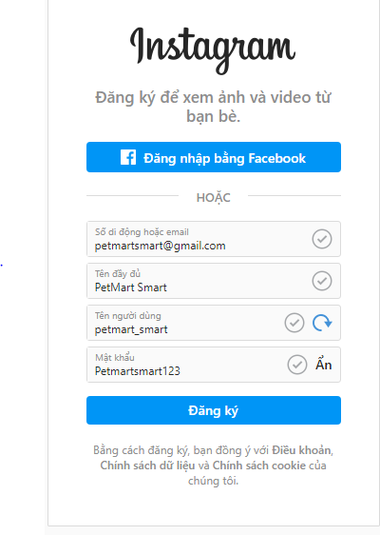

**tài khoản mk website**

**tk : admin**

**mk :Hoainguyen123@**

**mk 44k222nhom10**

**link web :**[**http://petmartsmart.com/wp-login.php?redirect_to=http%3A%2F%2Fpetmartsmart.com%2Fwp-admin%2F&reauth=1**](http://petmartsmart.com/wp-login.php?redirect_to=http%3A%2F%2Fpetmartsmart.com%2Fwp-admin%2F&reauth=1)

**Onesign:** [**petmartsmart@gmail.com**](mailto:petmartsmart@gmail.com)

**MK: Petmartsmart12\***